AI Lab Assignment 8.1
Task1: Password Strength Validator – Apply AI in Security Context
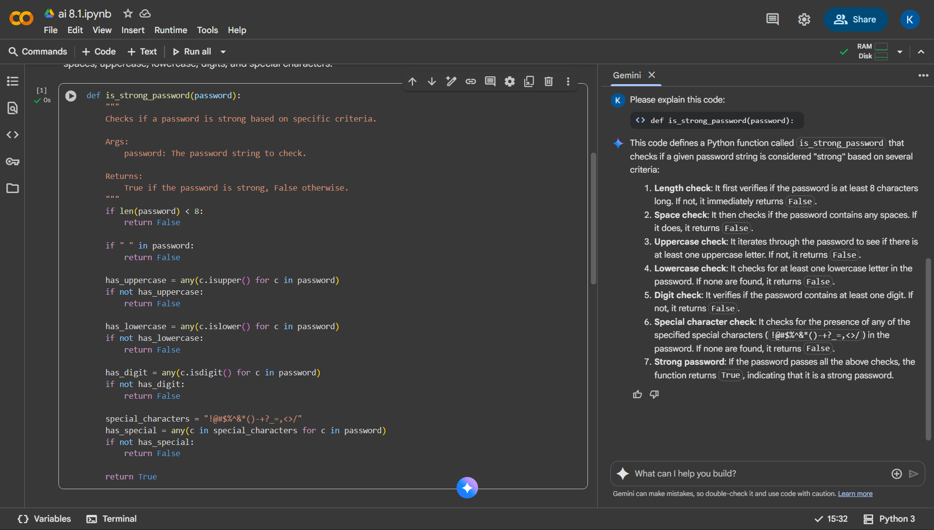
Task 2: Number Classification with Loops – Apply AI for Edge Case Handling
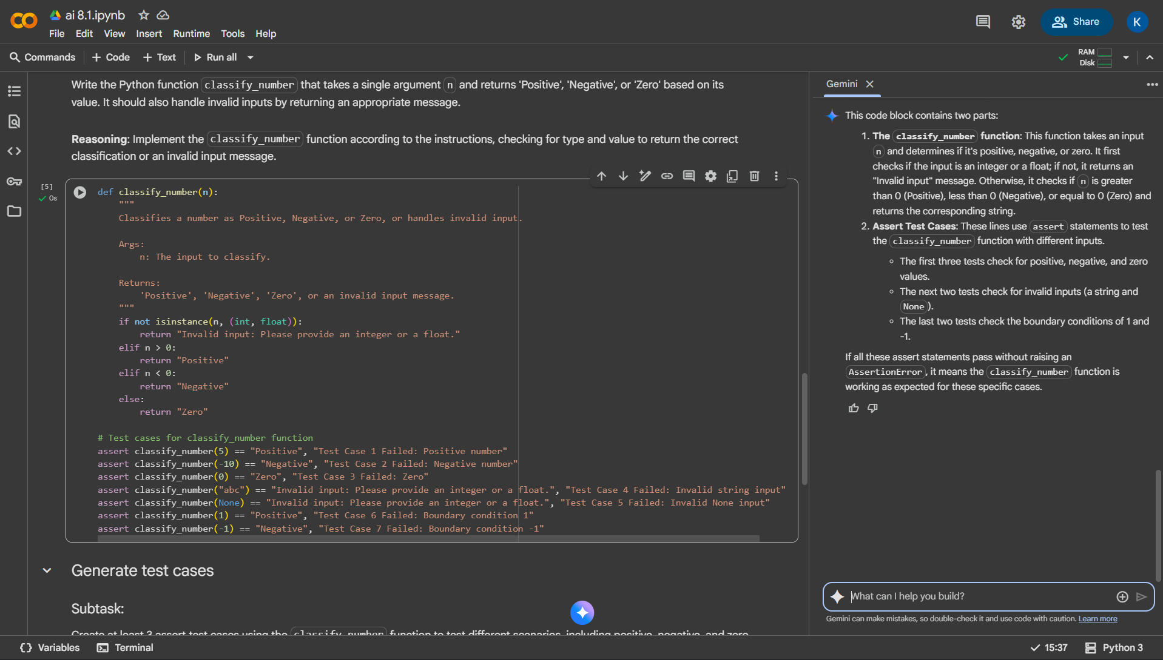

Task 3: Anagram Checker – Apply AI for String Analysis
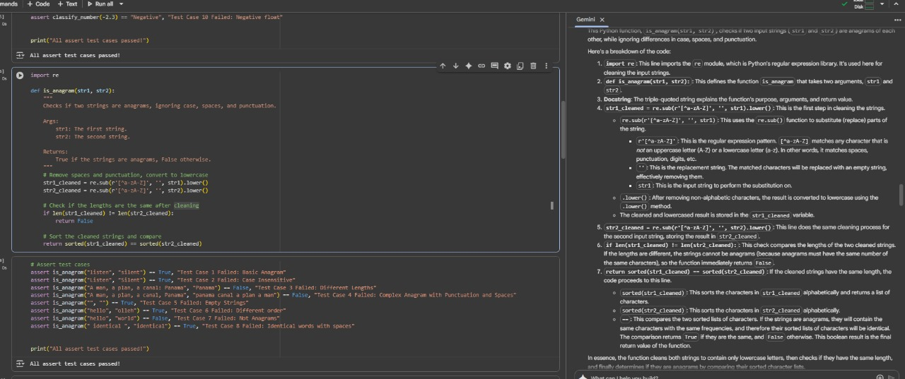
Task 4: Inventory Class – Apply AI to Simulate Real-World Inventory System
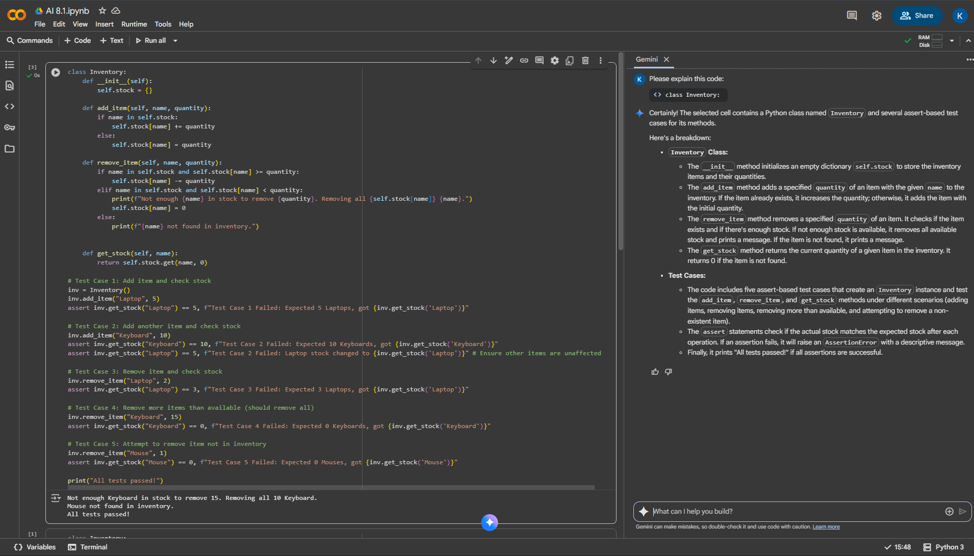

Task 5: Date Validation & Formatting – Apply AI for Data Validation
